This is to demonstrate how to setup rapidjson in MSVS 2010.

1. Go to <https://github.com/miloyip/rapidjson/> and download rapidjson.
2. Right click your MSVS project, open the property Page -> Include Directories, add the include file directory, for example, “*C:\backup\rapidjson_master\include*”：

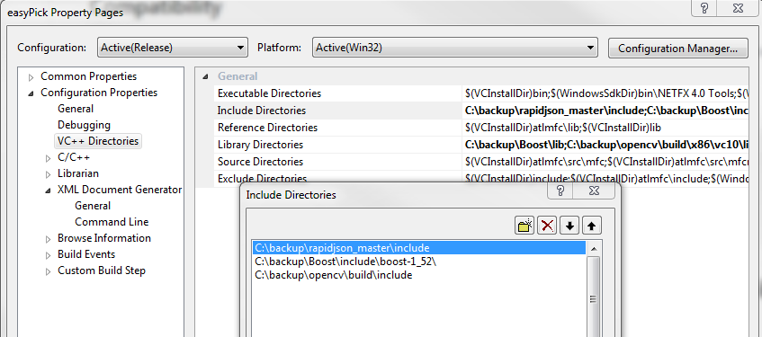

1. In your .cpp file, include necessary header files. Here is an example:

